Construction-Driven Execution Design Challenge: PUMP IT UP (Template)

Contents

I. Introduction 2

II. Excavation Calculations 2

III. Foundation Calculations 3

IV. Hydraulic Calculations Explanation 5

V. Modularization (Pros and Cons) 7

VI. Zero Based Execution (show calculations) 7

VII. Risk Assessment 8

VIII. Innovation Idea 8

## Introduction

The AquaDucks team is composed of three mechanical engineers who wanted to push the limits of their problem-solving abilities. Joseph Amar, the team lead, works for NASA as a co-op student at Johnson Space Center. Zach McBurney works as an engineering intern at an industrial services company in South Houston, and Saul Pizano has significant experience with CAD modeling and prototyping, but seeks to hone his other engineering skills.

This task was most difficult to complete from a time perspective. The challenge was almost two weeks underway when we learned of it, making every second count that much more. This was the greatest difficulty of the whole project: finding a team, gaining a firm grasp of the challenge and its interconnected variables, developing techniques to parametrize and optimize these variables with respect to cost, and doing it all in about three weeks while balancing school and our personal obligations. But these are the challenges which are most rewarding.

The three most important/useful lessons gained through this process were:

1. We are always capable of accomplishing more than we initially think is possible.
2. Your solution can only take advantage of combinatorics if you know what that word means.
3. Heroic efforts are all well and good, but consistency is much more valuable: do a little bit at a time, regularly, until you cross the finish line.

## Excavation Calculations

Excavation calculations were performed by casting the pipeline onto a 2-dimensional xy-coordinate system. We are given the elevation at each junction (y-value) and the distance along the pipeline (Fig. 1). From this information, calculating the x-values at each junction is trivial. The system is then divided up into 20,000 separate sections, each one covering ten feet of the pipeline. These sections are each assigned a soil type based on the given information, and these soil types are each built into dictionaries with the attributes maximum bearing pressure, maximum slope, foundation depth, and excavation cost. The derivation[1] for iteratively calculating how much soil needs to be excavated to create a 500’x500’ flat section is in the accompanying work. In this idealized scenario, it was determined that numerical integration using the trapezoidal rule will yield an exact solution.

This amount of soil is given as a volume (Fig. 2); this volume is used to determine the number of track-hoe-days necessary to excavate this amount of soil. Since this needs to be an integer, floor division was used, and a 1 added to the result. E.g., if a track hoe can move 100 [ft3/day] and the excavation calls for 450 [ft3] to be moved, then floor division (450 [ft3]//[100 ft3/day]) = 4 [track-hoe-days]. Adding 1 to the result means we end up with 5 [track-hoe-days], so one track hoe could finish it in five days, or five track hoes could do it in one day. A simple check of where the excavation occurs tells what the soil type is, determining whether it needs to be multiplied by a factor of three (for stable rock only). This section of code[2] outputs a list sorted by the actual excavation cost by junction, with soil type, track hoe usage, and dump truck usage. Dump truck usage is calculated by a method identical in concept to the track hoe method.

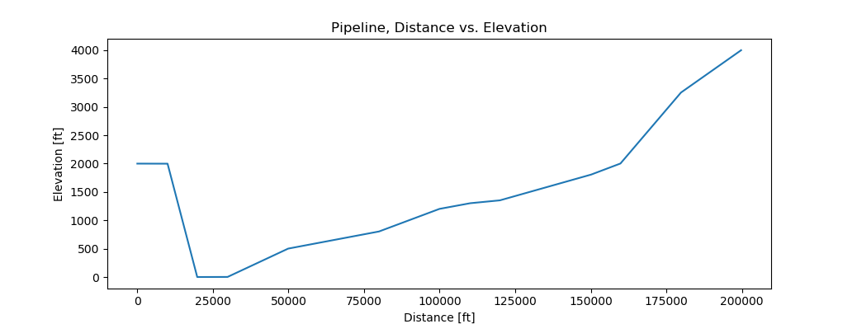

Figure 1. The xy-coordinate system of the pipeline.

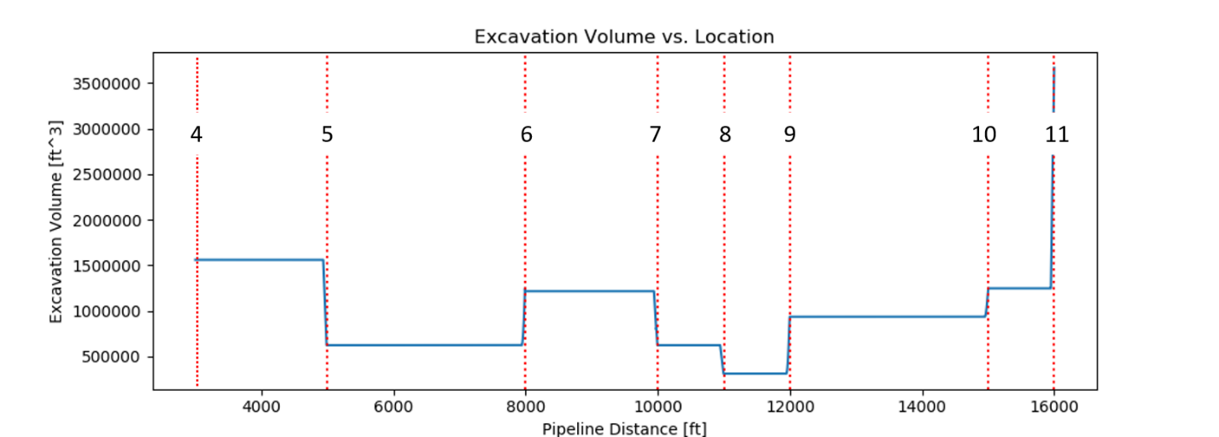

Figure 2. Excavation volumes compared to distance along pipeline. The dotted vertical lines denote junction locations; any 500'x500' excavation must overlap a junction.

## Foundation Calculations

Calculating the foundation dimensions was easier than it initially seemed. To perform the foundation optimization calculations, it was first necessary to determine which pumps were viable at each possible excavation site[3]. Because the running variable[4] contained dictionaries for all viable pump/junction combinations, we used this list as the “foundation” from which to base the calculations. An important part of this process was that the length and width of the baseplate were put into separate key-value pairs within the Python dictionaries; this made programmatically determining the length/width of the pedestal much simpler[5]. While the development of the iteration technique was difficult, the solution turned out to be quite simple: no possible combination of pump and pedestal exceeds the soil bearing pressure. Therefore, no footing was necessary in any configuration. This decreased complexity and cost of excavation; however, the included Python script still has the capability to determine footing size if parameters were to change. A standard concrete unit-weight of 145 [lb/ft3] was used, and a floor division technique similar to the dump truck and track hoe method was used to determine the concrete-truck-days required. Figure 3 shows the interconnected variables for this portion.

Once foundation size was determined, the last piece was to excavate the necessary volume in order to safely pour the foundation on which the pump will sit. This was done by first determining the soil type at the pump location. According to calculations in the excavation derivation, if the soil type changes at the junction, preference for the foundation location should be awarded to the material with a higher maximum slope *unless* that material is rock[6]. By these parameters, digging into stable rock is never preferable and should be avoided.

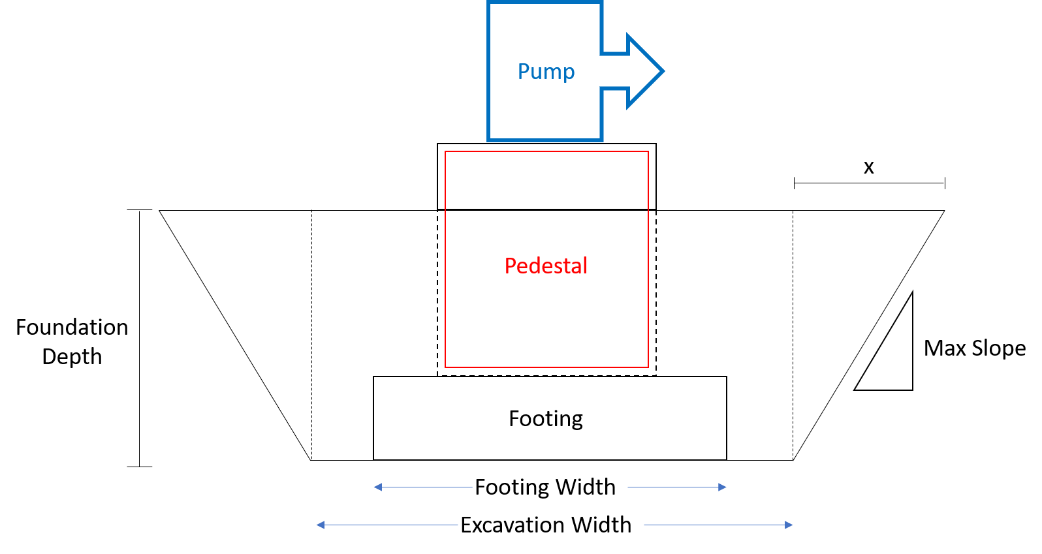

Figure 3. Excavation requirements for pump foundation. The mass of the foundation over its ground contact area must not exceed the soil's maximum bearing pressure. With known pump size and concrete density, the ideal foundation can be calculated from the information in the figure (see MathCAD for derivation).

## Hydraulic Calculations Explanation

The hydraulics portion of the design consists of the pipe thicknesses along with the pump choice and location. Using the AFT Fathom software, it was quickly established that with all else held equal, the maximum static pressure in the system would be minimized by placing the pump location further toward the pipeline outlet. However, this minimization technique has a built-in limiter: the pump cannot be placed so far down the line that the pressure at its inlet is negative. In fact, each pump has a criterion known as Net Positive Suction Head (NPSH), which is the head required at its inlet in order to avoid cavitation. The NPSH Available (NPSHA) scales with the pressure in the line; so, place the pump too far down the line, and it will cavitate. Place it too close to the source, and it drives up the maximum pressure in the system, increasing the required wall thickness (and cost) for the pipes, which are the most expensive portion by far. This relationship is evident in Figure 4.

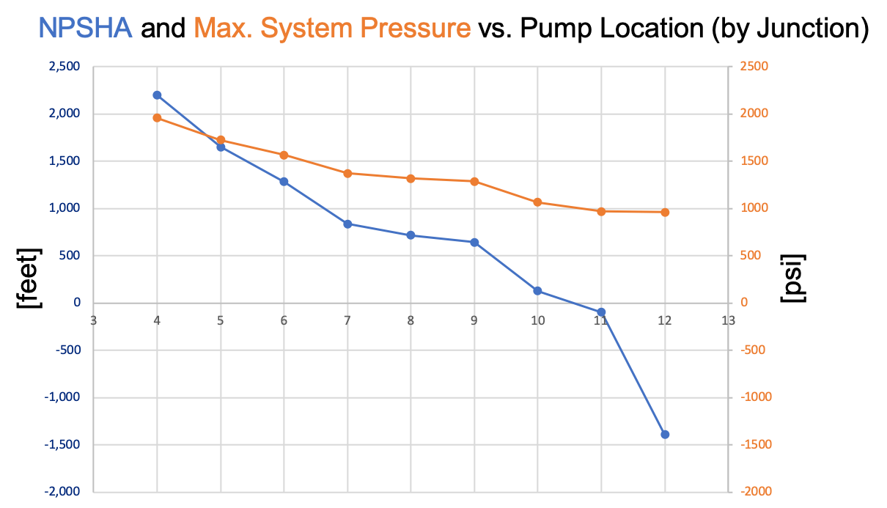

Figure . Relationship between NPSHA and System Pressure. As the distance from the pressurization source increases, the pressure and NPSHA fall. This is due to Bernoulli's equation, which asserts that, with all else held equal, as cumulative friction in a pipe increases (as it does with distance) the corresponding pressure must decrease.

Three major assumptions were made throughout this process:

1. Only the (5) different schedules of 30” pipe wall thickness available in AFT Fathom could be used in the various mill runs.
2. The decrease in static pressure caused by an increase in wall thickness (pressure dropped by < 1%) is negligible within the given constraints.
3. The density change of water under this project’s pressure variations can be safely ignored.

The selection of pipe thicknesses was initially (and incorrectly) assumed to be the easiest part, so it was saved for last. As directed, only the “STD” schedule wall thickness was used in the AFT Fathom simulation. The first three junctions were ignored, as they are within 30,000 feet of the starting location. Therefore, the simulation was run with the pump located at each of the junctions 4 through 12, and the results tabulated[7]. The horsepower is the same in all scenarios due to the physical principles of maintaining a given mass flow rate over a known distance. With these tabulated parameters, we were able to create a Python list of seven lists, each with 12 entries; the 12 entries represent the maximum static pressure at each pipe section, and the seven lists document the effect on these pressures of placing the pump at a different junction (4 through 10).

Pipe wall thickness optimization code was written in Python using “n choose k” combinatorics, a system which creates all possible k-length combinations from a set of n values. Since only three of five possible wall thicknesses can be chosen for the entire pipeline, every possible combination of three thicknesses was checked (10 total combinations). For each section along the pipeline, a “go/no-go” check was performed on the thickness with respect to that section’s gauge pressure—if the thickness is insufficient, the next higher thickness in that combination is checked—and the results were appended into lists of lists[8]. Each of these sub-lists with fewer than 12 entries was discarded, because this would mean that—for at least one of the 12 sections of pipe—no thickness in that combination was sufficient for that pump placement. From this point, calculating the volume, cost, and weight of each sub-list was trivial[9].

Estimating the crane costs, however, took a fair amount of Googling. According to LCS Pipelines [1], a cable crane can achieve up to 7 m/s line speed, which equates to 15.66 mph. With the chosen setup, 10980 tons of steel are required. With ten-hour work days and 50 days to complete the build, this gives us 500 hours in which the cranes must deposit every scrap of material. With a 12-ton lift capacity, this can be done in 915 crane trips. The average round trip for a crane will be equal to the total length of the pipeline: 37.9 miles. At 15.66 mph, this yields an average trip time of 2.42 hours. Multiplying this by our 915 trips yields total crane-hours: 2215 [crane-hours]. The following system optimizes the solution:

Solving, we determine that five cranes should be used for the first 215 hours, rounded up to 22 days, after which four cranes can be used for 285 hours, rounded down to 28 days. This yields a total of 2220 [crane-hours], an overage of only five hours. The Cost Spreadsheet will therefore reflect this overage: 6 cranes for 37 days. In conjunction with the required dump truck and track hoe schedules, this will leave the construction team ready to begin the foundation 10 days ahead of schedule. **Total Pipeline Cost: $84,191,812**

## Modularization (Pros and Cons)

There seems to be a tradeoff between weight and cost when it comes to modularization, at least for the pumps. In their modular forms, each pump is between about 24% to 38% less expensive, but weighs between 0% and 20% more, so it seems to be a good trade, at least when compared proportionally.

With that being said, the true benefit to the modularization is that complex components can be designed, and their pieces built well in advance of the on-site construction. This prevents the pressure of job-site stress from affecting the construction of important components; if it can be done while saving money, that’s even better. However, something like a pump wouldn’t be built on site, only installed. Modularization would make transport to the site easier, but it would also mean that the workers would need to assemble the pump in field. This introduces hazards such as improper assembly or, more likely, foreign objects or debris getting into critical areas.

## Zero Based Execution (show calculations)

The first thing that we changed for the ZBE was the surface area of the pump site. As directed, it was reduced to 200’x200’. Figure 5 shows how this affects the volume necessary to be excavated.

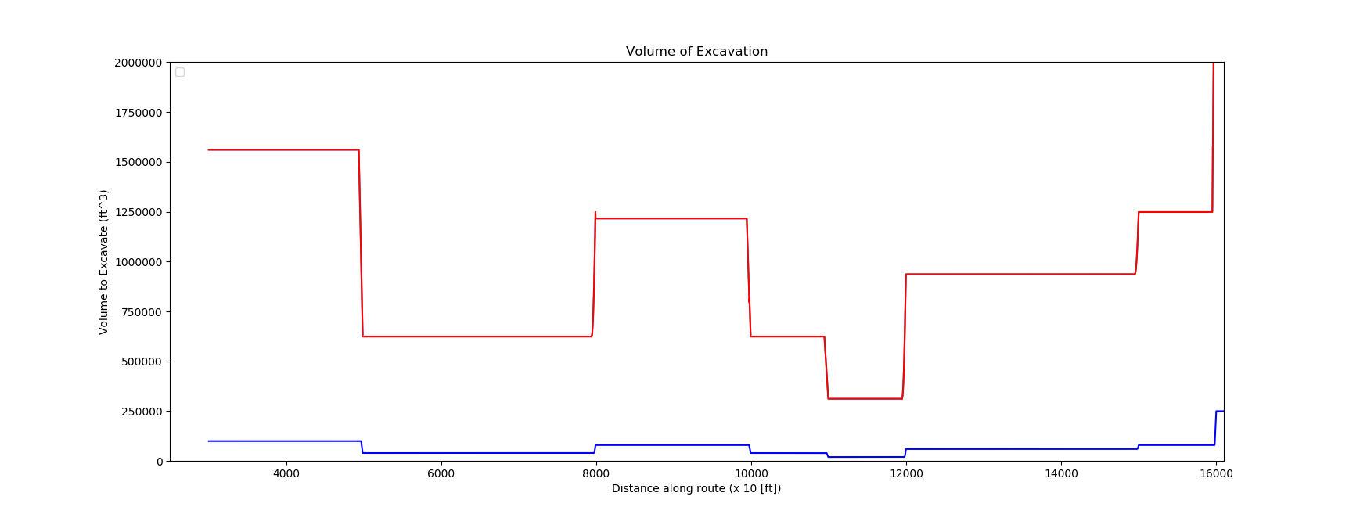

Figure . Volume to be excavated based on cut start location. Red shows the original requirement of a 500'x500' section, and the blue line shows the modified 200'x200' requirement.

It’s immediately apparent that these two lines can barely be shown on the same graph (at least a linearly spaced one), because their y-values differ by more than an order of magnitude. This difference is compounded even further when we consider that, in the ZBE calculations, we can use cut material as fill material. It can be shown mathematically[10] that a 100-foot flat cut that takes the removed material and uses it as filler requires exactly one fourth as much excavation as a 200-foot cut with no filling. This knowledge can be used to further reduce the number of trackhoe-hours. For this scenario, since the dump trucks do not need to go all the way back to wherever they came from but instead only to the start of the cut, it is a *very* conservative estimate to say that they could move at least 10 times as much material in a work day as they could before, if they’re now only moving it about 100 feet instead of 40 miles.

The next easy moneymaker (and the biggest project expense) is pipe sizing. When allowing the pumps to run 24/7, the mass flow rate gets divided by three, so a pipe ID with 1/3 the area of the previous model will be able to move the same amount of water per day. Being limited to a velocity of 8 ft/s, models were run in AFT Fathom and it was determined that a pipeline system with a baseline of 16-inch outer diameter and 15.5-inch inner diameter results in a velocity around 6.5 ft/s. This change in steel alone (if we used this .25” wall thickness throughout, which we won’t) would result in over $40 million saved on the project.

To calculate the actual savings, pumps need to be (virtually) installed in the pipeline, and the resulting sections evaluated for their pressures[11] in order to determine the required pipe schedule. Since each pump creates a pressure spike, an ideal (and unrealistic) scenario would have an infinite number of infinitely small pumps throughout the pipeline, in order to keep pressure constant throughout (innovation idea?). Since there is a large drop in elevation in the first 30,000 feet of the pipeline, adding pumps here doesn’t help. There will be a significant rise in pressure in the pipeline over the elevation drop that occurs in this range, and adding a pump here will only increase this high pressure further, resulting in high wall thickness requirements.

It was determined that two pumps, both of type F, could be added to the pipeline at junctions 9 and 11. Instead of creating one major pressure spike at a single pump location, this creates two minor pressure spikes, keeping the maximum pressure in each section low.

## Risk Assessment

## Innovation Idea

1. MathCAD
2. Fluor_script.py, lines 237 - 252
3. Fluor_script.py, lines 258 - 267
4. ‘solution_details’
5. The derivation of this technique is shown in the attached MathCAD file
6. This is due to the maximum allowable slope for each soil type. A steeper allowable slope means less horizontal digging is required to reach a given depth; it is therefore more efficient.
7. PressureTables.xlsx
8. Fluor_script.py, lines 377 - 400
9. Fluor_script.py, lines 411 – 422
10. MathCAD, ZBE Analysis, pg. 2
11. AFT Fathom, ZBE.fth